**Nama : Riofebri Prasetia**

**NIM : 221911192**

**Kelas : 3SI1**

**Tugas Analisis Peubah Ganda pertemuan 2**

link google syntax R : <https://colab.research.google.com/drive/1jDJdH57-hFXrLoNN8A6OsfG4yRap9Ahz?usp=sharing>

Berdasarkan data pada Exercise 1.3 Buku Jhonson & Wichern (2002),

Hitunglah:

1. Sample Covariance matrix (S) secara manual dengan
   1. memanfaatkan deviasi d_i

hasil:

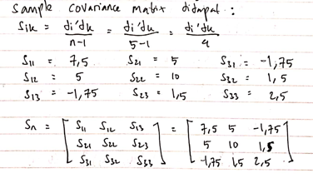

* 1. menggunakan rumus S=sum(xj-x_bar)(xj-x_bar)'/(n-1)

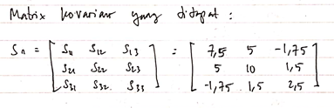

1. Sample Correlation matrix (R) dengan memanfaatkan matrik S

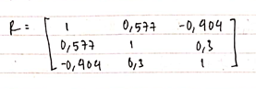

1. buatlah syntax R untuk nomor (1) dan (2) lalu bandingkan hasilnya dengan syntax yg sdh jadi di R: cov(data) dan cor(data)

# bikin syntax no 1 dan 2

#buat xbar  
xbar1<-mean(dataset1$x1)  
xbar2<-mean(dataset1$x2)  
xbar3<-mean(dataset1$x3)  
xbar1  
xbar2  
xbar3

[1] 6

[1] 8

[1] 2

***memanfaatkan deviasi untuk mencari matrix covariance***

d1<-matrix(dataset1$x1)-xbar1*1  
d2<-matrix(dataset1$x2)-xbar2*1  
d3<-matrix(dataset1$x3)-xbar3*1  
matrix(c("d1",d1,"d2",d2,"d3",d3),6,3)

[,1] [,2] [,3]  
[1,] d1 d2 d3   
[2,] 3 4 1   
[3,] -4 0 2   
[4,] 0 -2 -2   
[5,] -1 -4 0   
[6,] 2 2 -1

n<-5  
s11<-t(d1)%*%d1/(n-1)  
s12<-t(d1)%*%d2/(n-1)  
s13<-t(d1)%*%d3/(n-1)  
s21<-t(d2)%*%d1/(n-1)  
s22<-t(d2)%*%d2/(n-1)  
s23<-t(d2)%*%d3/(n-1)  
s31<-t(d3)%*%d1/(n-1)  
s32<-t(d3)%*%d2/(n-1)  
s33<-t(d3)%*%d3/(n-1)  
  
#covarians matrix  
cm1<-matrix(c(s11,s12,s13,s21,s22,s23,s31,s32,s33), 3, 3)  
cm1

[,1] [,2] [,3]   
[1,] 7.50 5.0 -1.75  
[2,] 5.00 10.0 1.50  
[3,] -1.75 1.5 2.50

***menggunakan S=sum(xj-x_bar)(xj-x_bar)'/(n-1) untuk mencari matrix covariance***

ss11<-sum((dataset1$x1-xbar1)*(dataset1$x1-xbar1))/(n-1)  
ss12<-sum((dataset1$x1-xbar1)*(dataset1$x2-xbar2))/(n-1)  
ss13<-sum((dataset1$x1-xbar1)*(dataset1$x3-xbar3))/(n-1)  
ss21<-sum((dataset1$x2-xbar2)*(dataset1$x1-xbar1))/(n-1)  
ss22<-sum((dataset1$x2-xbar2)*(dataset1$x2-xbar2))/(n-1)  
ss23<-sum((dataset1$x2-xbar2)*(dataset1$x3-xbar3))/(n-1)  
ss31<-sum((dataset1$x3-xbar3)*(dataset1$x1-xbar1))/(n-1)  
ss32<-sum((dataset1$x3-xbar3)*(dataset1$x2-xbar2))/(n-1)  
ss33<-sum((dataset1$x3-xbar3)*(dataset1$x3-xbar3))/(n-1)  
cm2<-matrix(c(ss11,ss12,ss13,ss21,ss22,ss23,ss31,ss32,ss33),3,3)  
cm2

[,1] [,2] [,3]   
[1,] 7.50 5.0 -1.75  
[2,] 5.00 10.0 1.50  
[3,] -1.75 1.5 2.50

matrix S yang menggunakan cara memanfaatkan deviasi memiliki hasil yang sama dengan matrix S yang menggunakan cara penjumlahan biasa untuk mencari covariance

***Sample Correlation matrix R dengan memanfaatkan matrix S***

#mencari D^(-0.5)  
matrixDiagonal<-matrix(c(s11^(-0.5),0,0,0,s22^(-0.5),0,0,0,s33^(-0.5)),3,3)  
matrixDiagonal

[,1] [,2] [,3]   
[1,] 0.3651484 0.0000000 0.0000000  
[2,] 0.0000000 0.3162278 0.0000000  
[3,] 0.0000000 0.0000000 0.6324555

#matrix Correlation  
mc <- matrixDiagonal%*%cm1%*%matrixDiagonal  
mc

[,1] [,2] [,3]   
[1,] 1.0000000 0.5773503 -0.4041452  
[2,] 0.5773503 1.0000000 0.3000000  
[3,] -0.4041452 0.3000000 1.0000000

# Matriks correlation and covariance dengan syntax R yang sudah jadi: cov(), cor()

cov(dataset1)

x1 x2 x3   
x1 7.50 5.0 -1.75  
x2 5.00 10.0 1.50  
x3 -1.75 1.5 2.50

cor(dataset1)

x1 x2 x3   
x1 1.0000000 0.5773503 -0.4041452  
x2 0.5773503 1.0000000 0.3000000  
x3 -0.4041452 0.3000000 1.0000000

**perbandingan:**

untuk hasil covariance dan correlation untuk syntax yang di buat dengan syntax yang sudah jadi di R memiliki hasil yang sama

1. eigen value & eigen vector dari kedua matrix S dan R secara manual, lalu bandingkan hasilnya dengan output R yang menggunakan syntax eigen()

**Matrix covariance :**

* Secara manual

Nilai eigen (eigen value)

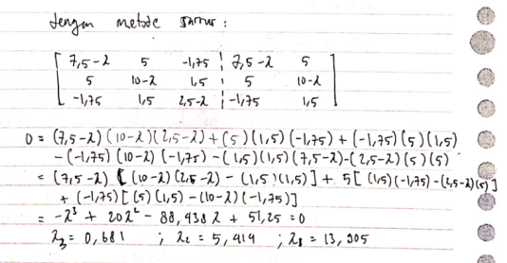

Eigen vector

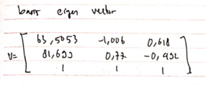

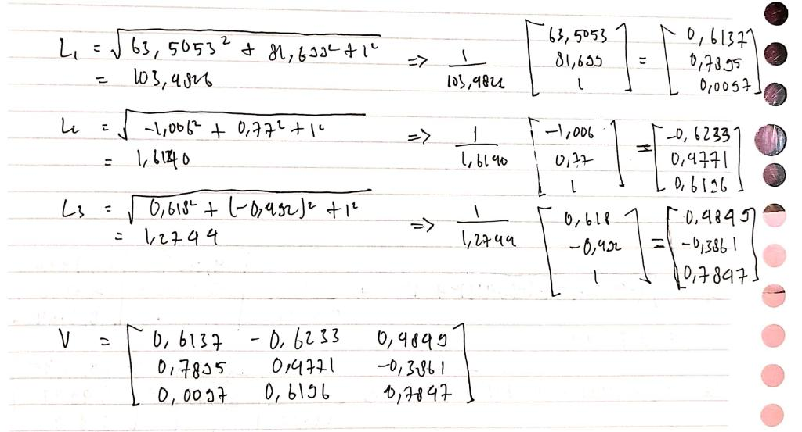

* Menggunakan R

$values  
[1] 13.9049009 5.4143634 0.6807358  
  
$vectors  
 [,1] [,2] [,3]  
[1,] -0.613679310 -0.6232975 0.4846627  
[2,] -0.789496144 0.4769002 -0.3863444  
[3,] -0.009671757 0.6197309 0.7847548

**Matrix Correlation**

* Secara Manual

Nilai eigen (eigen value)

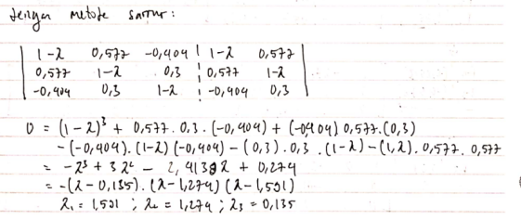

Eigen vector

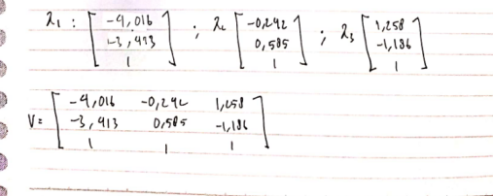

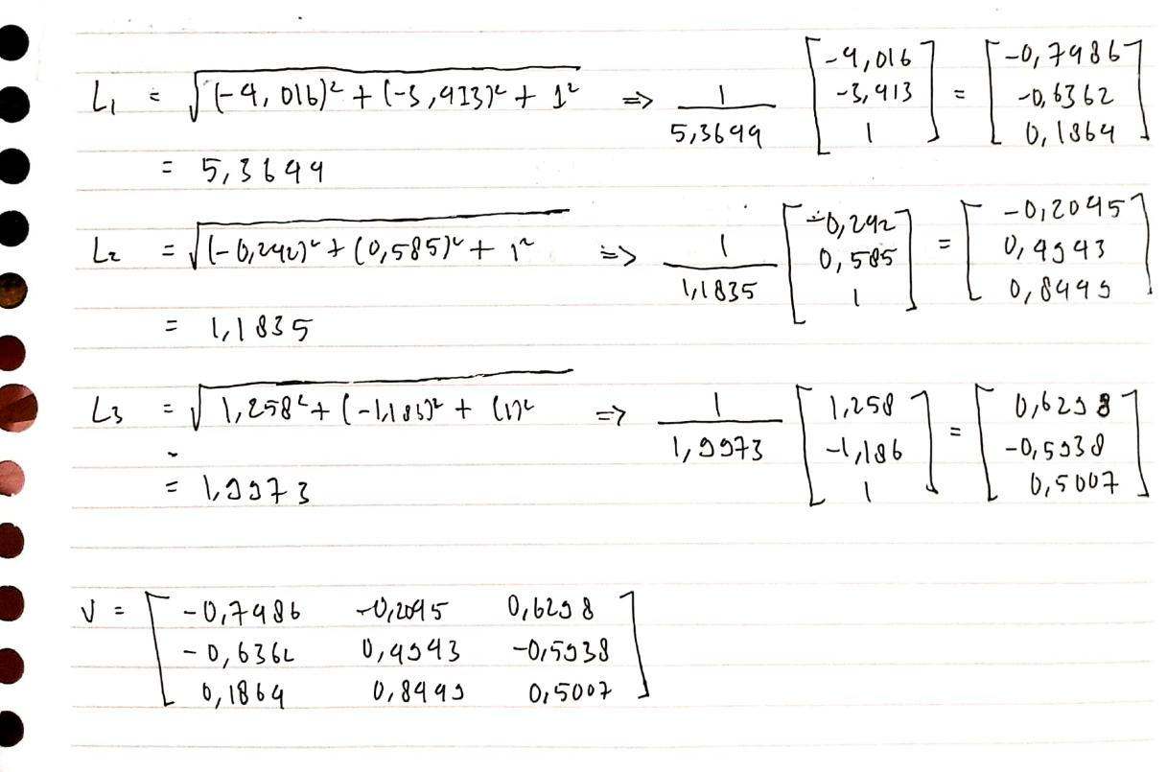

* Menggunakan R

$values  
[1] 1.591638 1.273514 0.134848  
  
$vectors  
 [,1] [,2] [,3]  
[1,] 0.7490653 -0.2047782 0.6300533  
[2,] 0.6347139 0.4943479 -0.5939347  
[3,] -0.1898407 0.8447994 0.5002744

**Perbandingan hasil manual dengan R:**

Nilai eigen dan eigen vector pada cara manual memiliki hampir kesamaan atau mendekati dengan syntax R yang sudah jadi.

**Lampiran pengerjaan secara manual**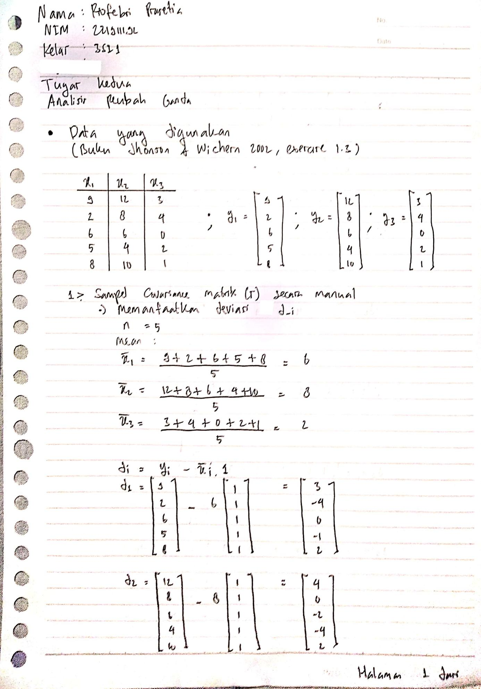

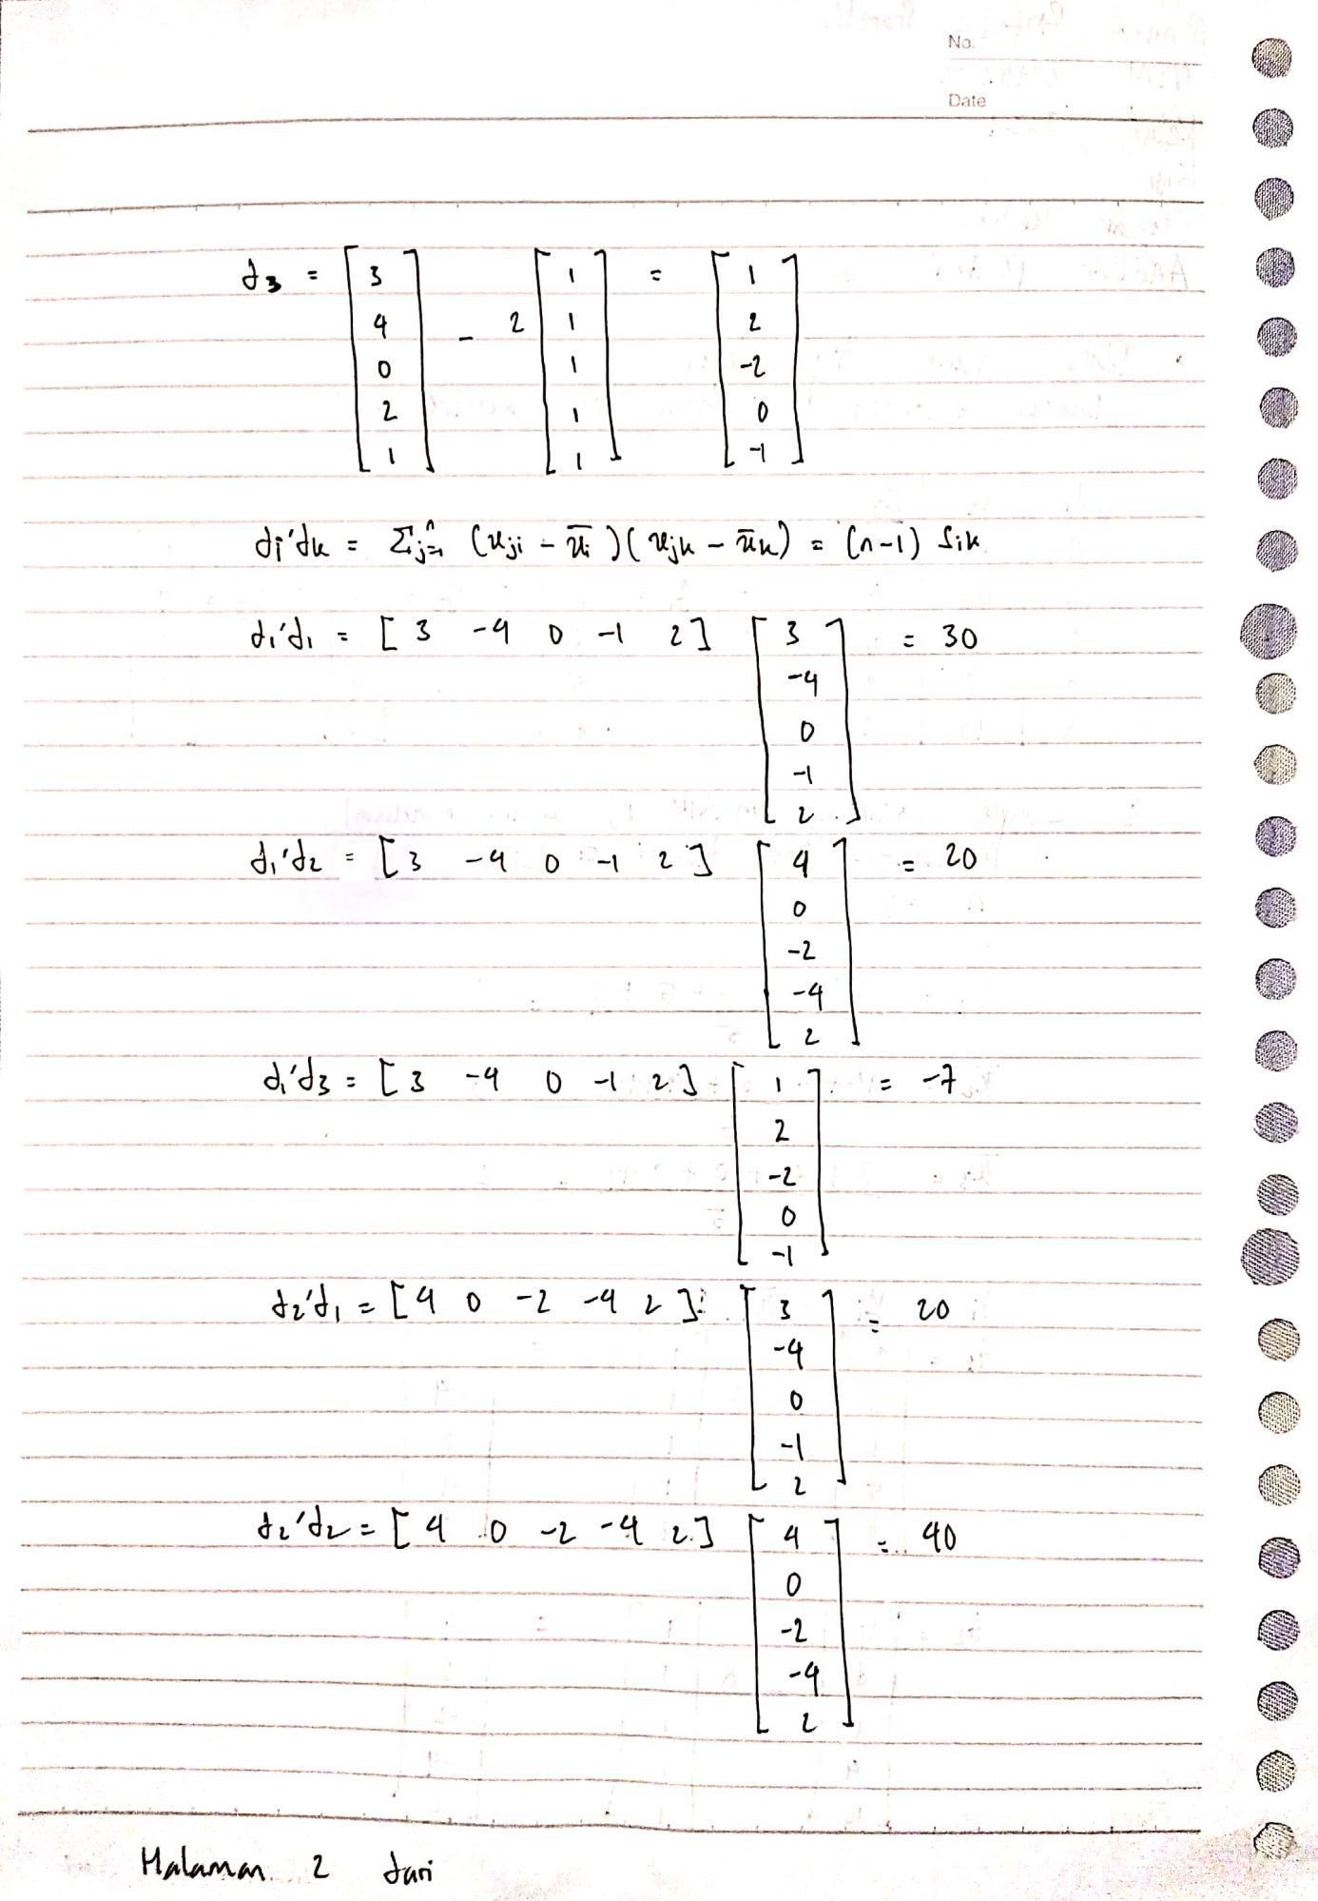

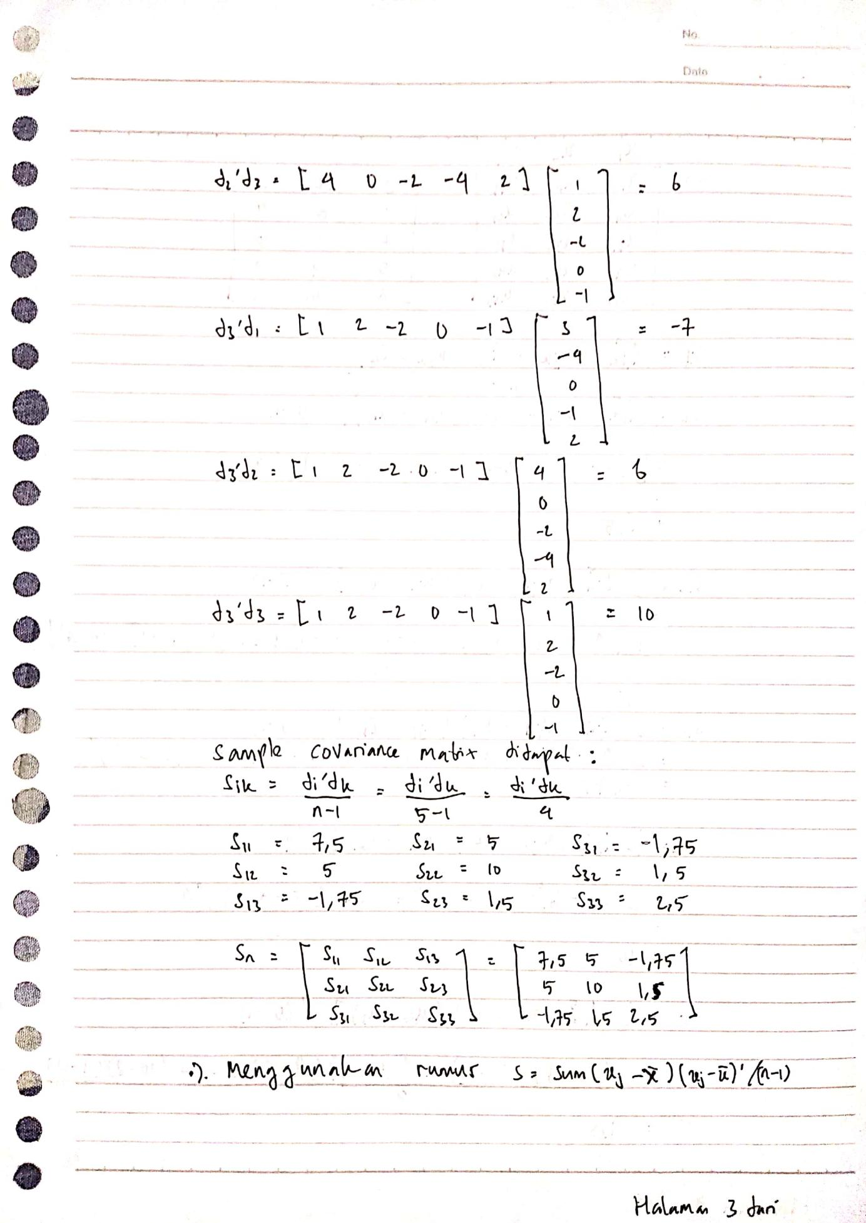

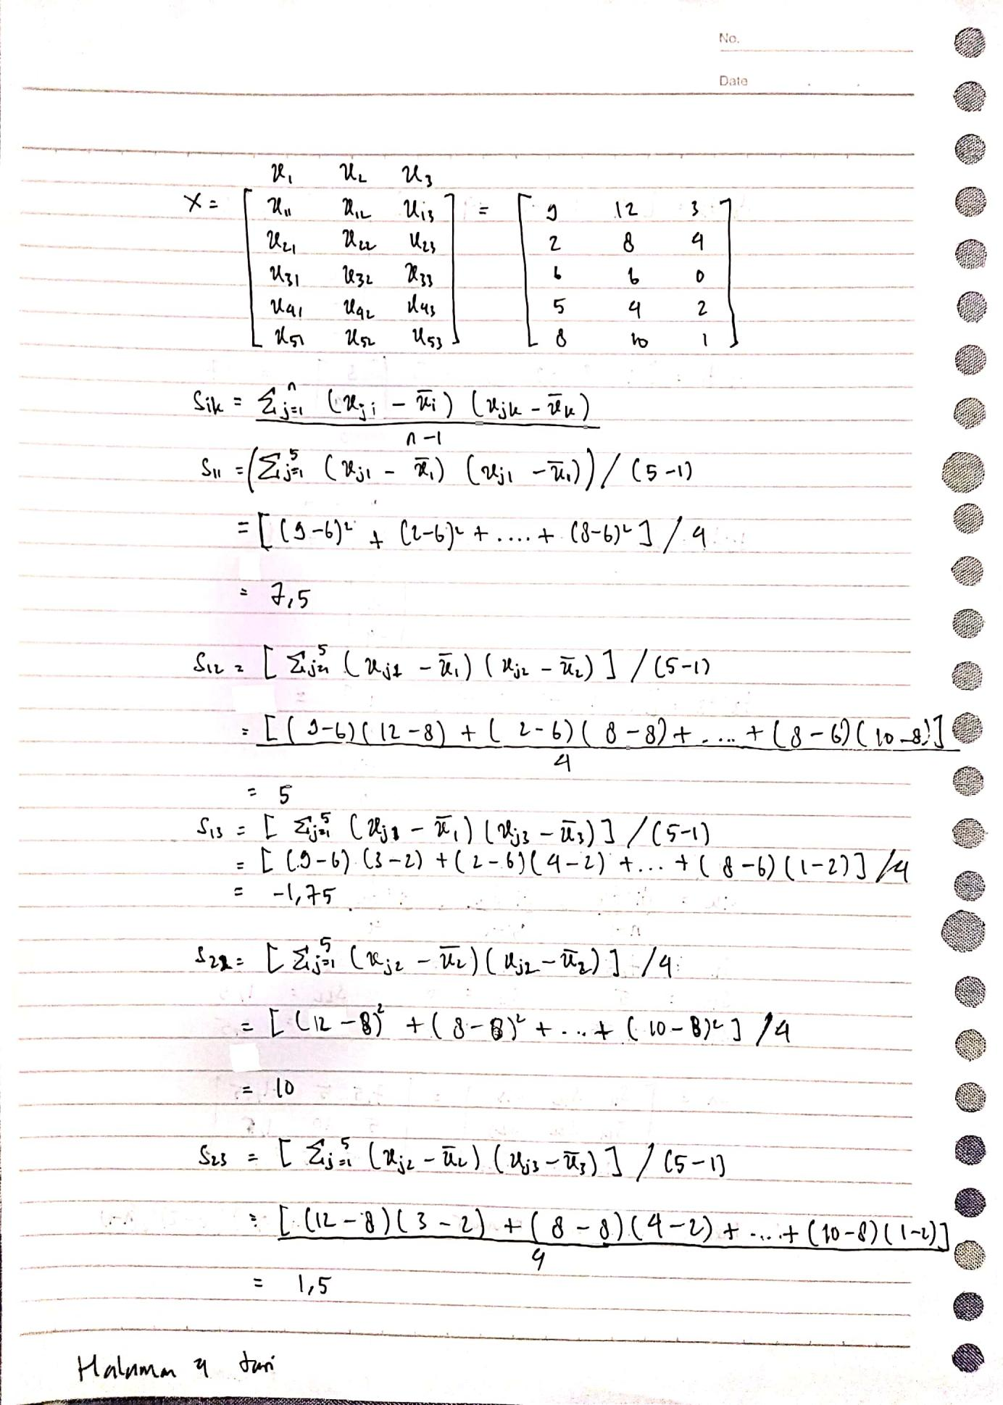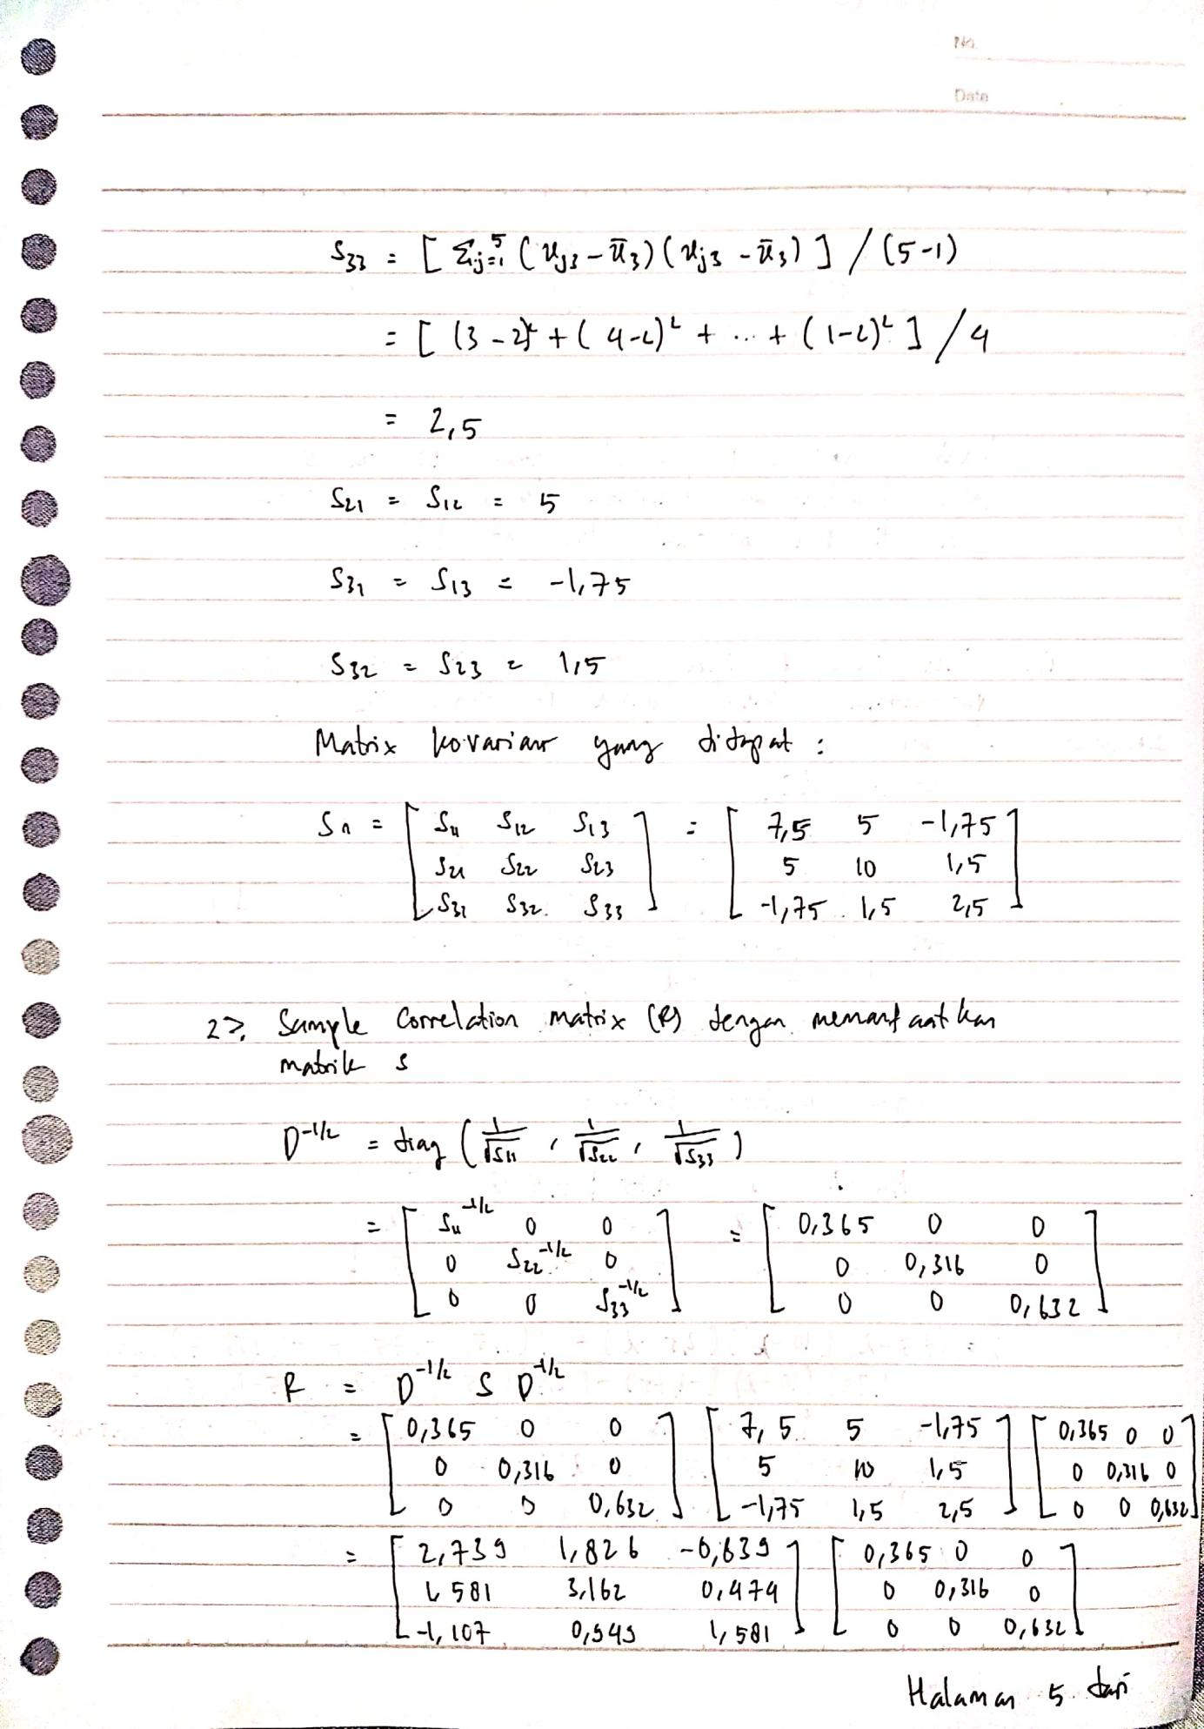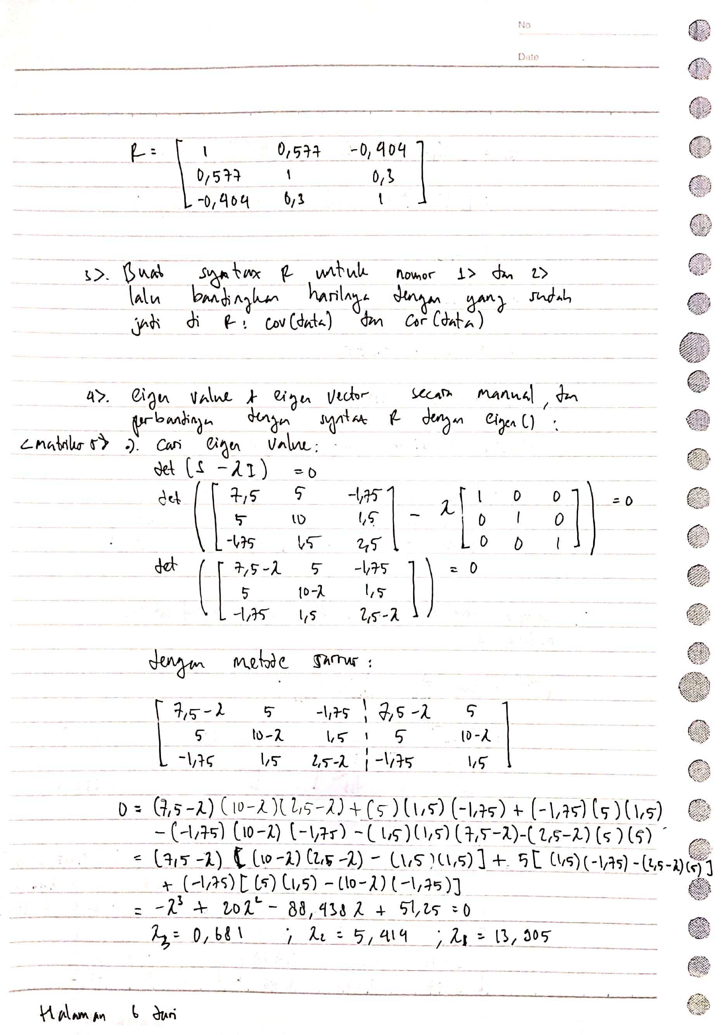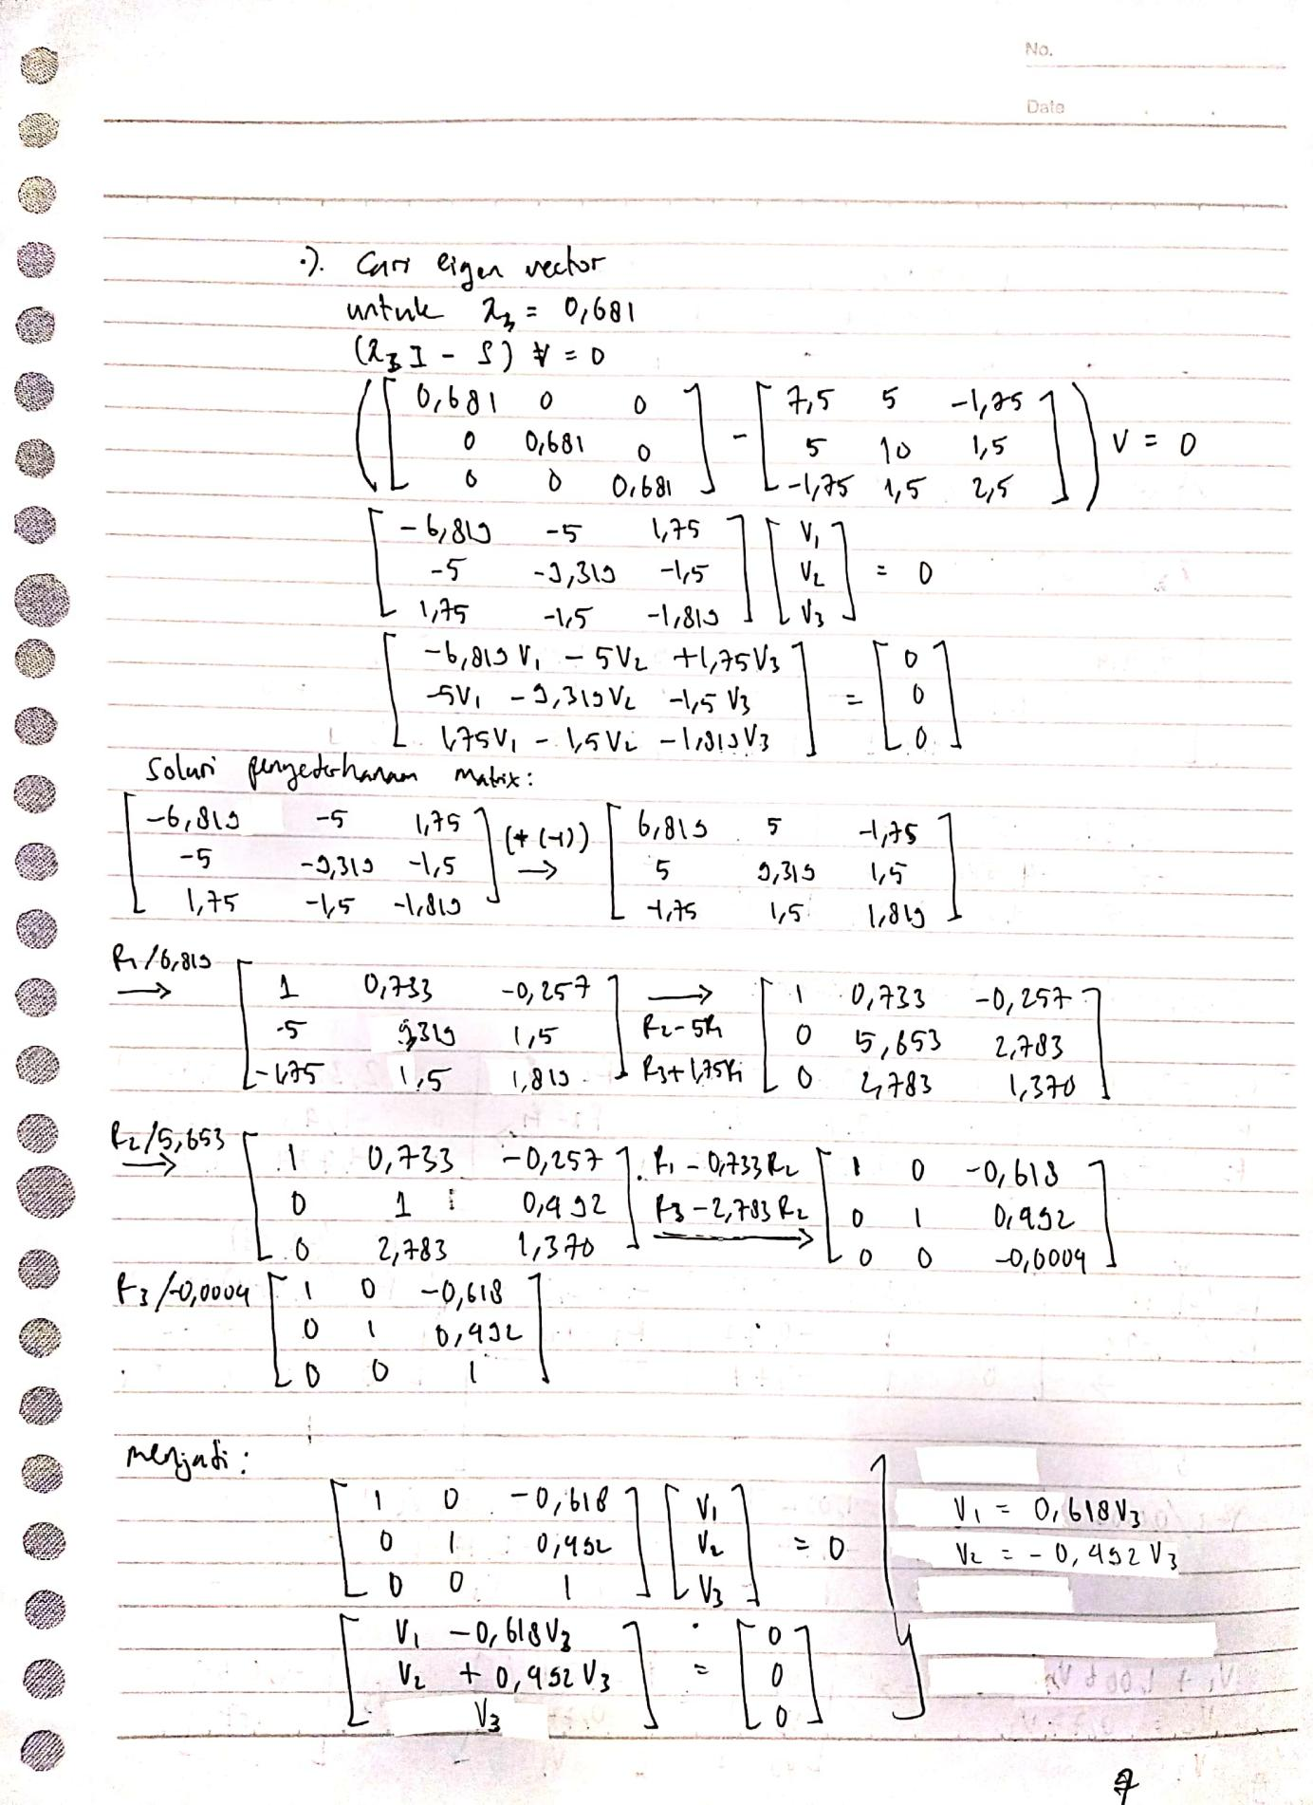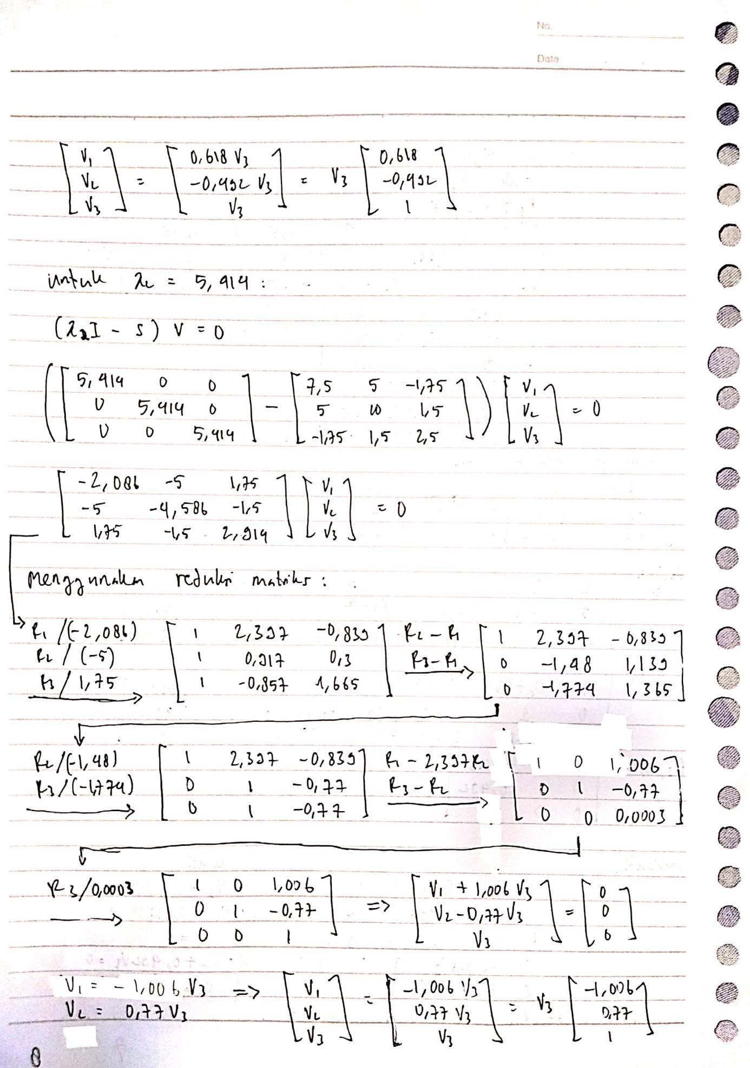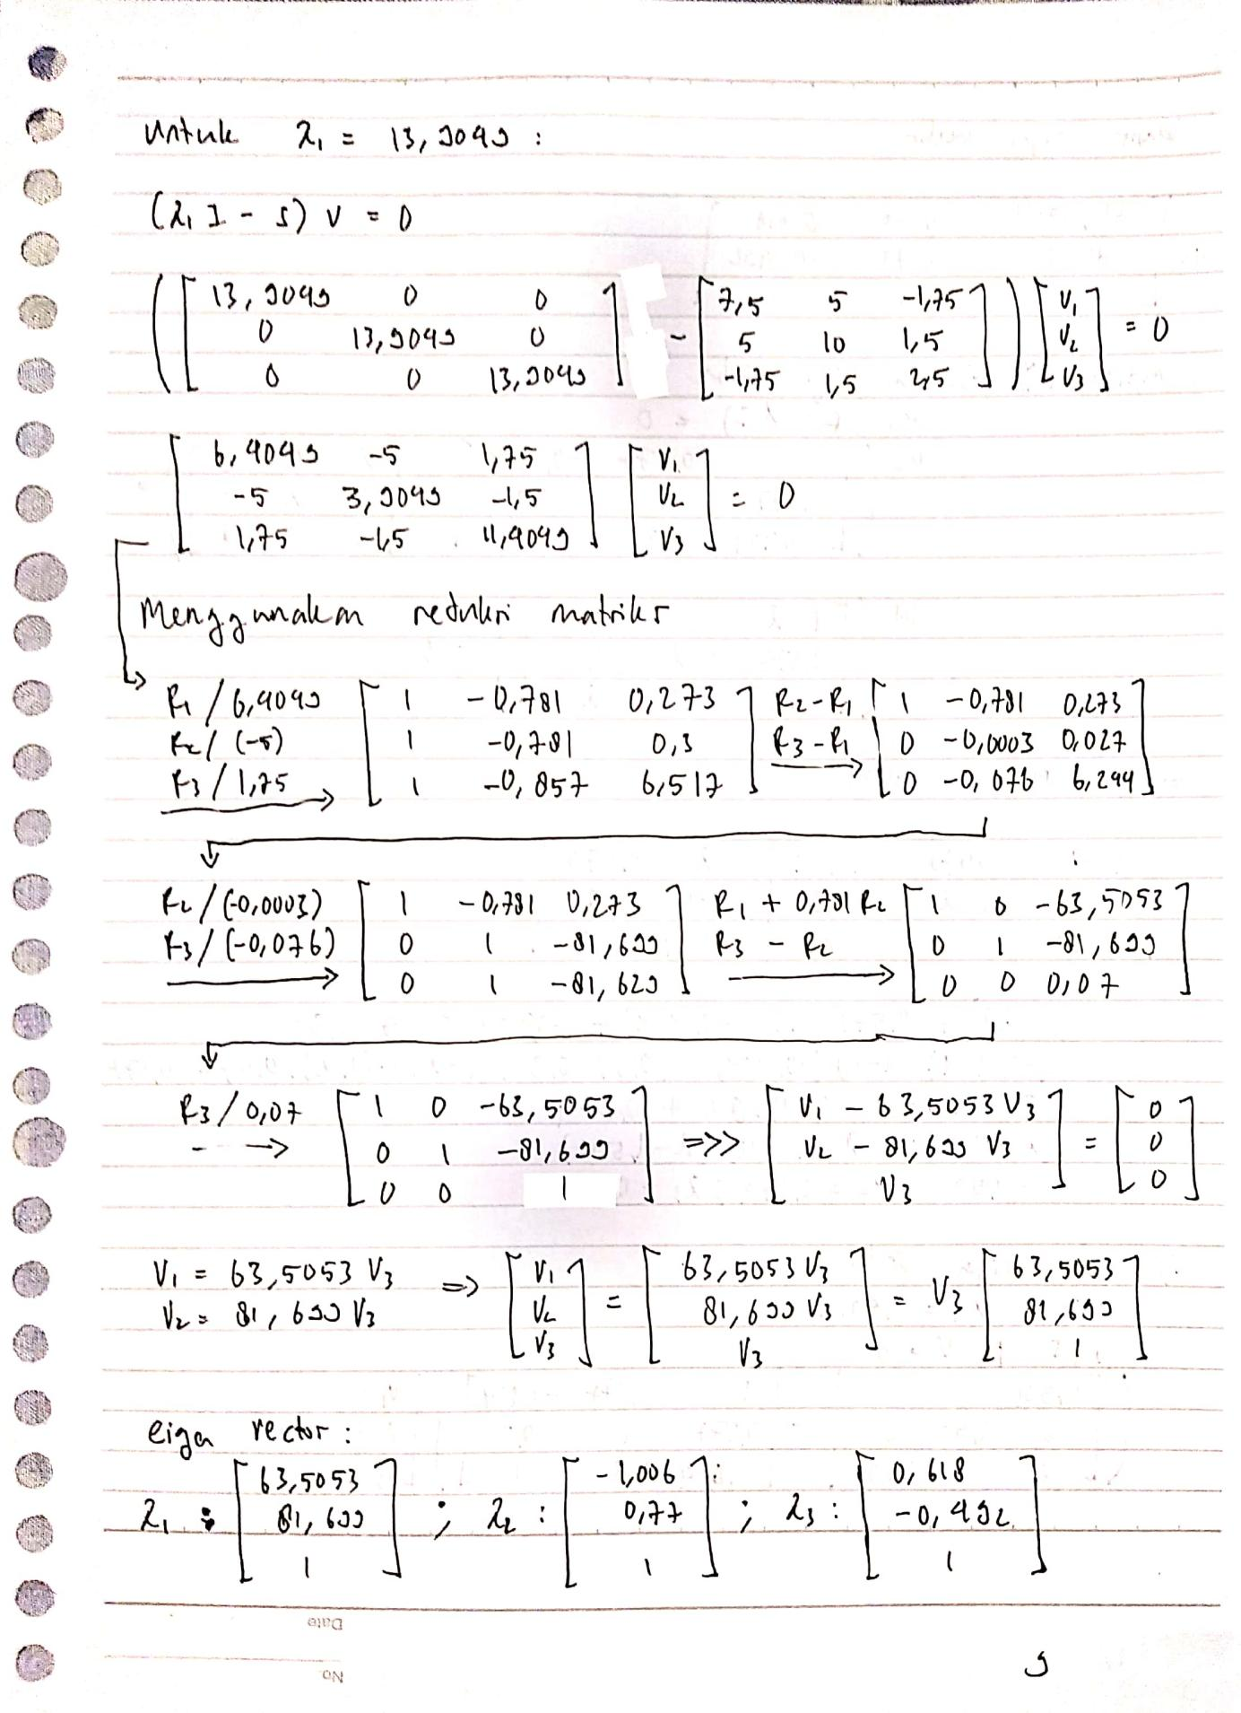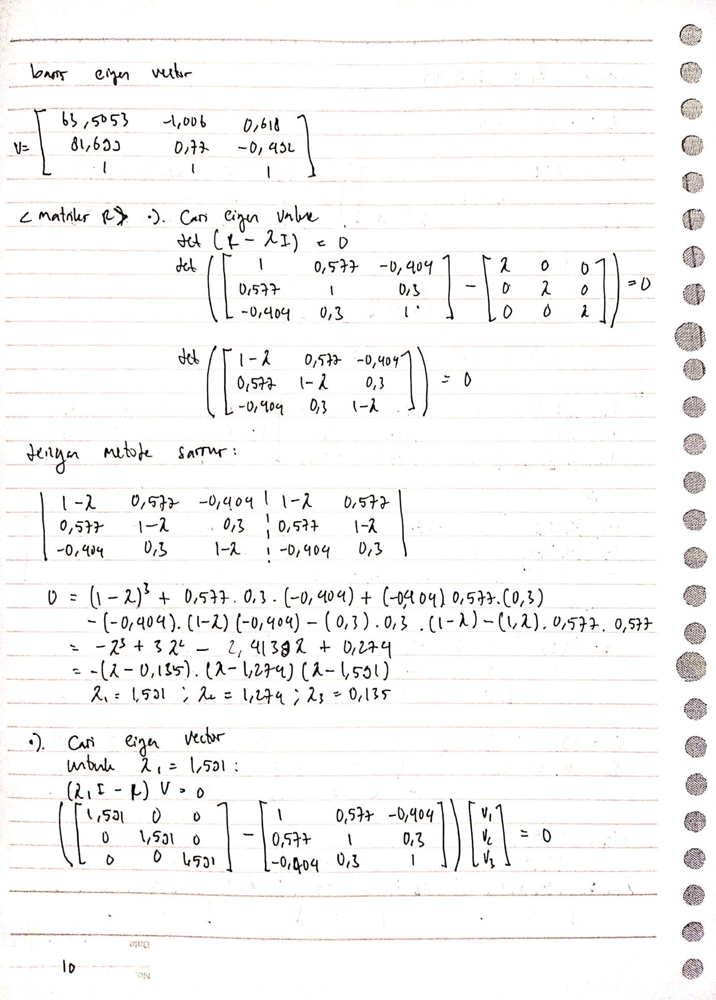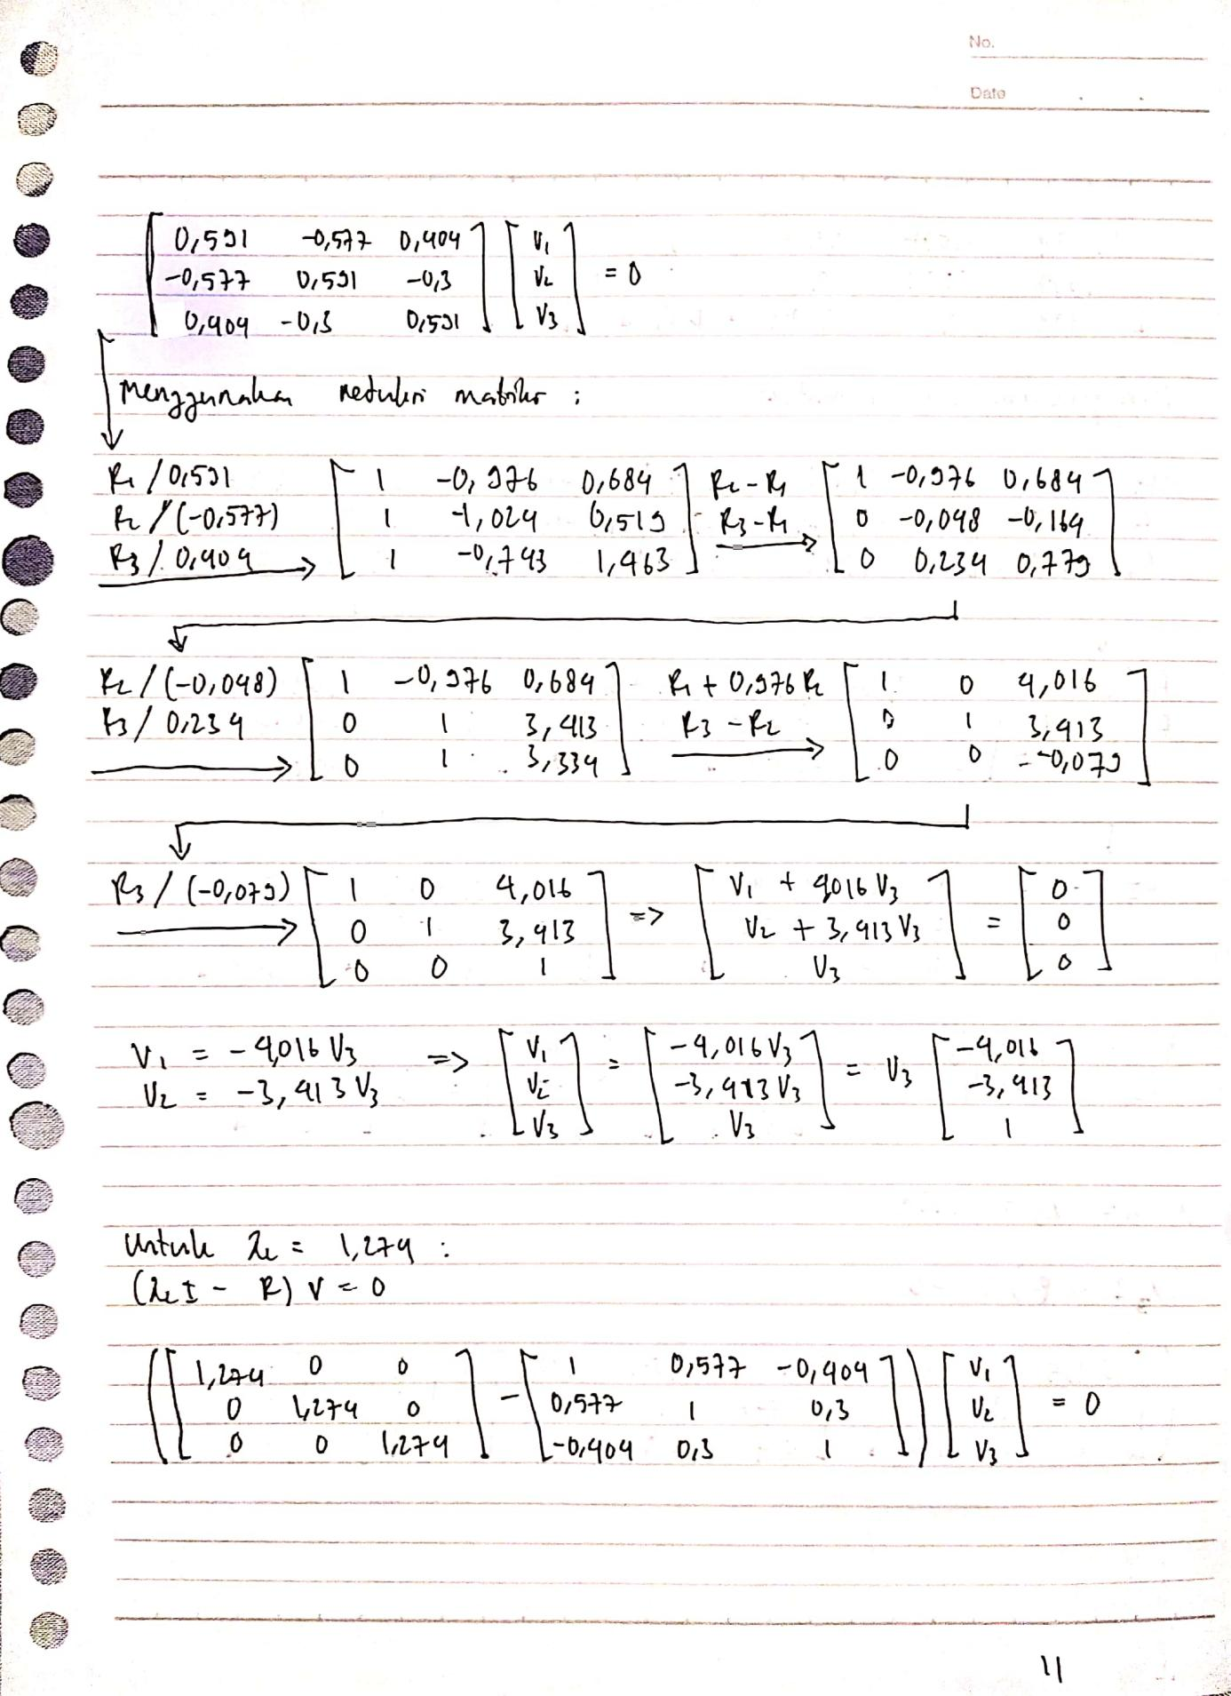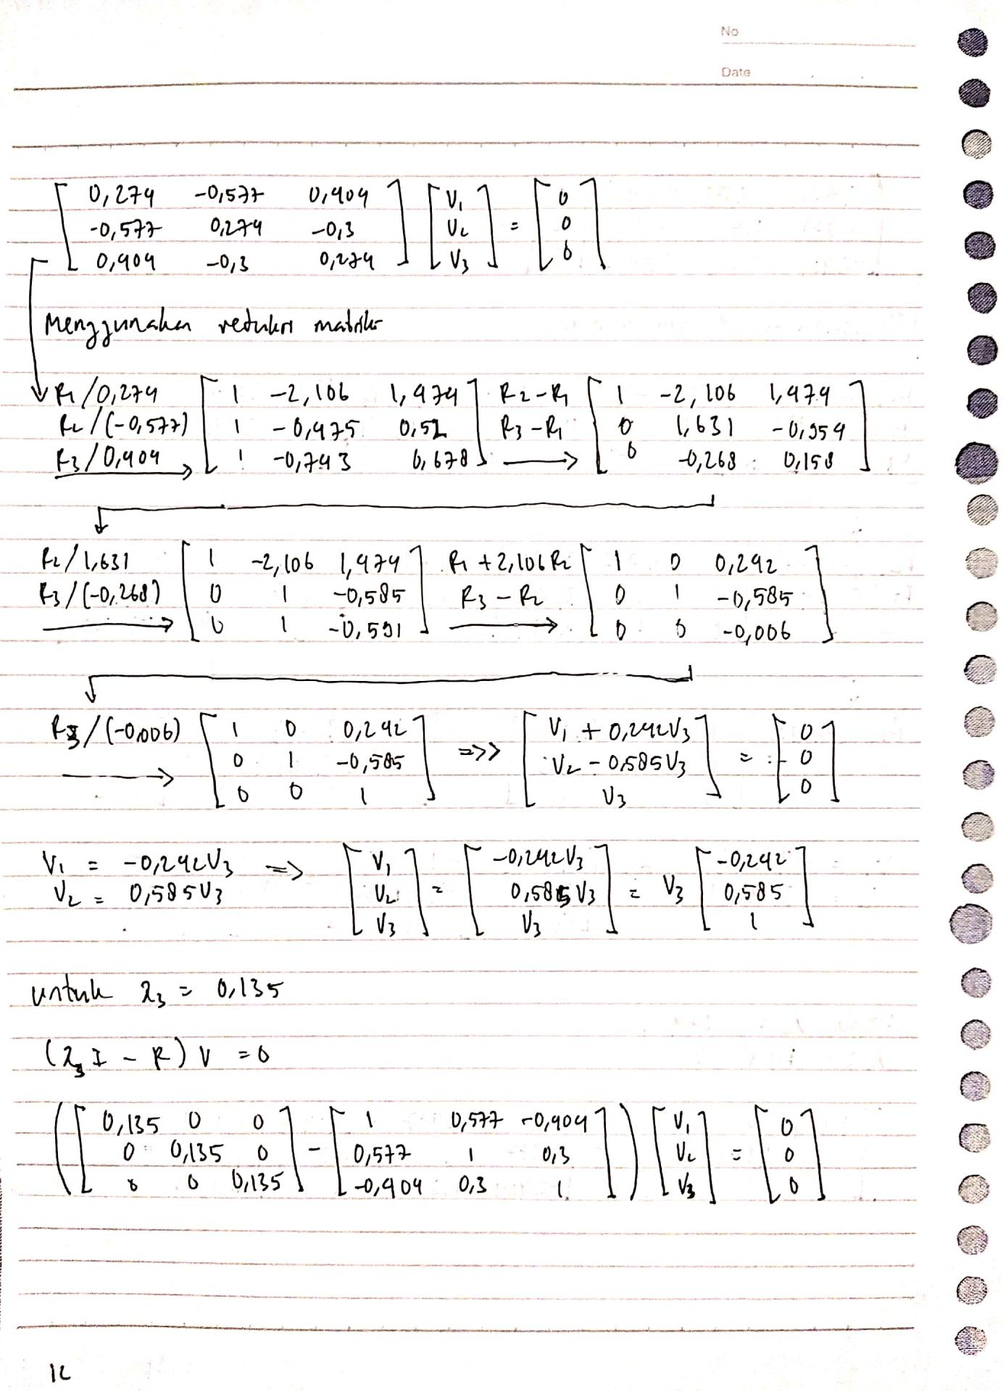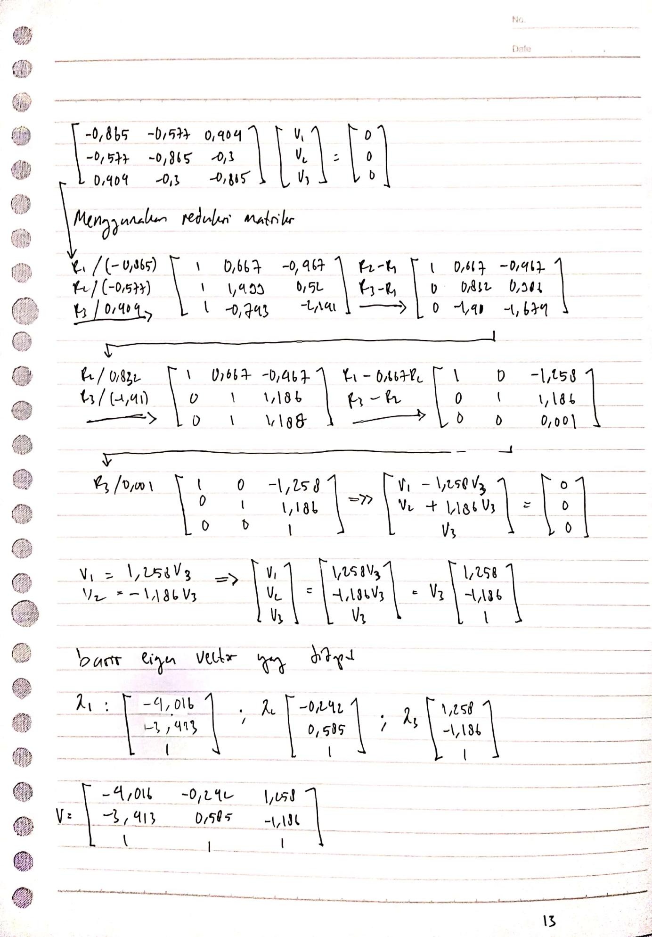

Lampiran syntax R

# Dataset yang digunakan

url<-"https://raw.githubusercontent.com/rii92/tugas-APG/main/28%20februari%202022/tugas%20kedua%20APG.csv"  
dataset1 <- read.csv(url, sep = ",")  
dataset1

x1 x2 x3  
1 9 12 3   
2 2 8 4   
3 6 6 0   
4 5 4 2   
5 8 10 1

# bikin syntax no 1 dan 2

#buat xbar  
xbar1<-mean(dataset1$x1)  
xbar2<-mean(dataset1$x2)  
xbar3<-mean(dataset1$x3)  
xbar1  
xbar2  
xbar3

[1] 6

[1] 8

[1] 2

***memanfaatkan deviasi untuk mencari matrix covariance***

d1<-matrix(dataset1$x1)-xbar1*1  
d2<-matrix(dataset1$x2)-xbar2*1  
d3<-matrix(dataset1$x3)-xbar3*1  
matrix(c("d1",d1,"d2",d2,"d3",d3),6,3)

[,1] [,2] [,3]  
[1,] d1 d2 d3   
[2,] 3 4 1   
[3,] -4 0 2   
[4,] 0 -2 -2   
[5,] -1 -4 0   
[6,] 2 2 -1

n<-5  
s11<-t(d1)%*%d1/(n-1)  
s12<-t(d1)%*%d2/(n-1)  
s13<-t(d1)%*%d3/(n-1)  
s21<-t(d2)%*%d1/(n-1)  
s22<-t(d2)%*%d2/(n-1)  
s23<-t(d2)%*%d3/(n-1)  
s31<-t(d3)%*%d1/(n-1)  
s32<-t(d3)%*%d2/(n-1)  
s33<-t(d3)%*%d3/(n-1)  
  
#covarians matrix  
cm1<-matrix(c(s11,s12,s13,s21,s22,s23,s31,s32,s33), 3, 3)  
cm1

[,1] [,2] [,3]   
[1,] 7.50 5.0 -1.75  
[2,] 5.00 10.0 1.50  
[3,] -1.75 1.5 2.50

***menggunakan S=sum(xj-x_bar)(xj-x_bar)'/(n-1) untuk mencari matrix covariance***

ss11<-sum((dataset1$x1-xbar1)*(dataset1$x1-xbar1))/(n-1)  
ss12<-sum((dataset1$x1-xbar1)*(dataset1$x2-xbar2))/(n-1)  
ss13<-sum((dataset1$x1-xbar1)*(dataset1$x3-xbar3))/(n-1)  
ss21<-sum((dataset1$x2-xbar2)*(dataset1$x1-xbar1))/(n-1)  
ss22<-sum((dataset1$x2-xbar2)*(dataset1$x2-xbar2))/(n-1)  
ss23<-sum((dataset1$x2-xbar2)*(dataset1$x3-xbar3))/(n-1)  
ss31<-sum((dataset1$x3-xbar3)*(dataset1$x1-xbar1))/(n-1)  
ss32<-sum((dataset1$x3-xbar3)*(dataset1$x2-xbar2))/(n-1)  
ss33<-sum((dataset1$x3-xbar3)*(dataset1$x3-xbar3))/(n-1)  
cm2<-matrix(c(ss11,ss12,ss13,ss21,ss22,ss23,ss31,ss32,ss33),3,3)  
cm2

[,1] [,2] [,3]   
[1,] 7.50 5.0 -1.75  
[2,] 5.00 10.0 1.50  
[3,] -1.75 1.5 2.50

matrix S yang menggunakan cara memanfaatkan deviasi memiliki hasil yang sama dengan matrix S yang menggunakan cara penjumlahan biasa untuk mencari covariance

***Sample Correlation matrix R dengan memanfaatkan matrix S***

#mencari D^(-0.5)  
matrixDiagonal<-matrix(c(s11^(-0.5),0,0,0,s22^(-0.5),0,0,0,s33^(-0.5)),3,3)  
matrixDiagonal

[,1] [,2] [,3]   
[1,] 0.3651484 0.0000000 0.0000000  
[2,] 0.0000000 0.3162278 0.0000000  
[3,] 0.0000000 0.0000000 0.6324555

#matrix Correlation  
mc <- matrixDiagonal%*%cm1%*%matrixDiagonal  
mc

[,1] [,2] [,3]   
[1,] 1.0000000 0.5773503 -0.4041452  
[2,] 0.5773503 1.0000000 0.3000000  
[3,] -0.4041452 0.3000000 1.0000000

# Matriks correlation and covariance dengan syntax R yang sudah jadi: cov(), cor()

cov(dataset1)

x1 x2 x3   
x1 7.50 5.0 -1.75  
x2 5.00 10.0 1.50  
x3 -1.75 1.5 2.50

cor(dataset1)

x1 x2 x3   
x1 1.0000000 0.5773503 -0.4041452  
x2 0.5773503 1.0000000 0.3000000  
x3 -0.4041452 0.3000000 1.0000000

# Eigen value and eigen vector

eigen(cov(dataset1))

eigen() decomposition  
$values  
[1] 13.9049009 5.4143634 0.6807358  
  
$vectors  
 [,1] [,2] [,3]  
[1,] -0.613679310 -0.6232975 0.4846627  
[2,] -0.789496144 0.4769002 -0.3863444  
[3,] -0.009671757 0.6197309 0.7847548

eigen(cor(dataset1))

eigen() decomposition  
$values  
[1] 1.591638 1.273514 0.134848  
  
$vectors  
 [,1] [,2] [,3]  
[1,] 0.7490653 -0.2047782 0.6300533  
[2,] 0.6347139 0.4943479 -0.5939347  
[3,] -0.1898407 0.8447994 0.5002744